VEHICLE SERVICE MANAGEMENT PLATFORM
Project submitted to the
SRM University – AP, Andhra Pradesh
for the partial fulfilment of requirements to award the degree of
Bachelor of Technology
In
Computer Science and Engineering
School of Engineering and Sciences
Submitted by
P. Venkata Thapan – AP23110010044
V. Jeshnav – AP23110010074
S. Ramu – AP23110010004
K. Ruthvik – AP23110010073


Under the Guidance of,
Dr. Ravi Kant Kumar
Associate Professor, Dept. of CSE

SRM University-AP
Neerukonda, Mangalagiri, Guntur
Andhra Pradesh – 522 240
April 2026

CERTIFICATE
Date: 28-04-2026
This is to certify that the work present in this Project entitled “VEHICLE SERVICE MANAGEMENT PLATFORM” has been carried out by P. Venkata Thapan, V. Jeshnav, S. Ramu and K.Ruthvik under my supervision. The work is genuine, original, and suitable for submission to the SRM University – AP for the award of Bachelor of Technology in School of Engineering and Sciences.

Supervisor
(Signature)
Dr. Ravi Kant Kumar
Associate Professor
Department of CSE

ACKNOWLEDGEMENT
I would like to express my profound gratitude to everyone who supported me throughout the development of the Vehicle Service Management Platform.
My deepest appreciation goes to my faculty guide, Dr. Ravi Kant Kumar, for his invaluable guidance, continuous encouragement, and constructive feedback. His profound technical insights and mentorship were instrumental in shaping the architecture and successful execution of this project.
I also want to extend my sincere thanks to SRM University-AP for providing the necessary resources and an environment conducive to learning and innovation.
Finally, I am deeply thankful to my family and friends for their unwavering support and motivation during the challenging phases of this software development journey.

ABSTRACT
The automotive service industry frequently faces operational bottlenecks due to manual record-keeping, fragmented communication, and inefficient scheduling. This project presents the development of the Vehicle Service Management Platform, a comprehensive, web-based Software-as-a-Service (SaaS) application engineered to digitize and automate the entire vehicle repair workflow. Developed utilizing the robust MERN stack (MongoDB, Express.js, React.js, and Node.js), the system introduces a highly secure, Role-Based Access Control (RBAC) architecture that serves four distinct user entities: Administrators, Service Centers, Technicians, and Customers.
The core of the platform is built upon a strict, linear service lifecycle state machine. It seamlessly guides a service request from the initial customer booking to service center approval, technician assignment, real-time repair tracking, and automated invoice generation. By integrating Redux Toolkit for complex frontend state management and JSON Web Tokens (JWT) for secure backend authentication, the application ensures high performance and data integrity. The resulting platform eliminates manual dispatching errors, provides vehicle owners with total transparency over their repair status, and equips service centers with a centralized dashboard to track labor, parts, and billing. Ultimately, this system successfully modernizes the garage ecosystem, increasing operational efficiency and elevating the overall customer experience.

TABLE OF CONTENTS

1. INTRODUCTION
1.1 Overview
The automotive service industry relies heavily on efficient communication, precise record-keeping, and timely execution of mechanical repairs. However, many service centers still depend on fragmented, manual systems to handle appointments, track repair progress, and manage customer billing. The Vehicle Service Management Platform is a modern, web-based Software-as-a-Service (SaaS) application designed to digitize and unify the entire vehicle servicing lifecycle. Built on the robust MERN (MongoDB, Express.js, React, Node.js) stack, this platform bridges the gap between customers, mechanics, and service center administration through an interactive and highly scalable digital infrastructure.

1.2 Problem Statement
Traditional vehicle servicing workflows suffer from several critical inefficiencies:
- Manual & Error-Prone Booking: Customers often face difficulties scheduling service slots, while service centers struggle with overlapping appointments and disorganized dispatching.
- Lack of Transparency: Vehicle owners have zero visibility into the real-time status of their repairs, leading to communication gaps and customer dissatisfaction.
- Disjointed Record Management: Technicians lack a streamlined way to log labor hours and parts used, making it difficult for administrators to generate accurate, timely invoices.
- Absence of Centralized Control: Tracking overall service metrics, managing workforce (technicians), and maintaining comprehensive service histories across multiple vehicles is highly challenging without a unified digital system.

1.3 Proposed Solution
The Vehicle Service Management Platform solves these industry pain points by providing a centralized, Role-Based Access Control (RBAC) ecosystem. It introduces four distinct, secure portals:
- Customer Portal: Allows fleet and private vehicle owners to register their vehicles, seamlessly book service appointments, track real-time repair states, and view final invoices.
- Service Center Portal: Acts as a dispatcher dashboard to approve incoming appointments, assign specific mechanics to jobs, and generate final billing upon completion.
- Technician Portal: A specialized interface for mechanics to view assigned tasks, log repair progress, record labor hours, and itemize utilized parts.
- Admin Portal: Provides system overlords with comprehensive oversight, user management, and global metrics.
By enforcing a strict service lifecycle state machine—ranging from "Pending Approval" to "Repair In Progress" and finally "Invoice Generated"—the system guarantees operational data integrity at every step.

1.4 Objectives
The primary objectives of this project include:
- To architect a secure, scalable web application that automates the end-to-end vehicle maintenance workflow.
- To implement strict Role-Based Access Control (RBAC) ensuring data privacy and operational boundaries for different user types.
- To provide real-time status tracking for customers, enhancing transparency and trust.
- To digitize the mechanic's clipboard, allowing technicians to digitally log service descriptions, parts, and labor directly linked to customer profiles.
- To automate financial documentation by instantly generating accurate invoices upon the completion of a service record.

1.5 Scope of the Project
The scope of this platform encompasses the full lifecycle of a vehicle service transaction. It includes secure user authentication (via JSON Web Tokens), dynamic vehicle registry management, a robust appointment scheduling engine, and a comprehensive digital service logbook. Additionally, the system incorporates automated invoice generation tied to labor and part costs. While the current scope delivers a complete, production-ready operational workflow, future iterations are designed to integrate live payment gateways and predictive maintenance AI.

2. OVERALL DESCRIPTION
2.1 Product Perspective
The Vehicle Service Management Platform is engineered as a standalone, comprehensive Software-as-a-Service (SaaS) web application. It acts as a centralized digital bridge replacing traditional, paper-based mechanic workflows and disjointed software solutions (like separate accounting and calendar apps). Developed utilizing the MERN stack (MongoDB, Express.js, React, Node.js), the platform leverages a RESTful API architecture. The React frontend consumes JSON data provided by the secure Node/Express backend, ensuring a highly responsive Single Page Application (SPA) experience.

2.2 System Features & Core Workflow
The system is built around a strict Service Lifecycle State Machine that ensures data integrity and chronological progression of vehicle repairs. The core workflow features include:
- Vehicle Registry & Booking: Customers register their fleet and initiate service requests.
- Dispatch & Assignment: Service Centers receive requests, approve them, and assign specific technicians based on availability and expertise.
- Digital Service Execution: Technicians log active repairs, update statuses (e.g., Repair In Progress to Completed), and record labor hours and parts utilized.
- Automated Billing: Upon completion of a service record, the system automatically generates a comprehensive invoice linked directly to the customer's profile.

2.3 User Classes and Characteristics
The application enforces strict Role-Based Access Control (RBAC), categorizing users into four distinct tiers, each with tailored dashboard interfaces and privileges:
- Customer (Fleet/Vehicle Owner): The end-user of the service. They require an intuitive interface to add vehicle details, book service appointments, track the real-time status of their repairs, and view generated invoices.
- Service Center (Dispatcher/Manager): Acts as the operational hub. They oversee incoming appointments, manage the technician workforce, dispatch jobs, and finalize billing. They need a comprehensive dashboard with high-level visibility of all daily operations.

- Technician (Mechanic): The executor of the repair. Their interface is highly focused on active job queues. They require tools to view vehicle histories, update repair statuses, and input labor and parts data efficiently.
- Admin (System Overlord): The super-user responsible for platform maintenance. Admins handle user management, provision new service centers and technicians, and monitor global system metrics and database integrity.

2.4 Operating Environment
- Client/Frontend: The frontend is a responsive web application designed to run on any modern web browser (Google Chrome, Mozilla Firefox, Safari, Microsoft Edge). It utilizes Tailwind CSS to ensure a seamless experience across desktop, tablet, and mobile displays.
- Server/Backend: The backend API operates on a Node.js runtime environment, utilizing Express.js for routing. It is designed to be hosted on scalable cloud infrastructure (such as AWS, Heroku, or Render).
- Database: The application utilizes MongoDB, a NoSQL database, capable of handling highly relational data via the Mongoose ODM (Object Data Modeling) library.

2.5 Design and Implementation Constraints
- Authentication Dependency: The platform relies heavily on JSON Web Tokens (JWT). All sensitive actions require a valid token in the HTTP Authorization header.
- Data Integrity Constraint: The system strictly prohibits the deletion of critical financial or service records to maintain historical accuracy. Instead, a "Soft Delete" architecture is implemented where users or records are marked inactive rather than being purged from the database.
- One-Time Generation: Invoices are bound to specific service records via mandatory unique indexing to prevent duplicate billing errors.

3. EXTERNAL INTERFACE REQUIREMENTS
3.1 User Interfaces (UI)
The platform is designed as a dynamic, Single Page Application (SPA) prioritizing user experience (UX) and responsive design.
- Design Language: The UI utilizes a premium design system featuring modern aesthetics such as Glassmorphism, tailored dark/light modes, and custom CSS keyframe animations to enhance interactivity.
- Responsiveness: Built with Tailwind CSS, the interface is completely fluid and automatically scales across desktops, tablets, and mobile devices without losing functionality.
- Role-Specific Dashboards:
  - Customers are presented with a clean interface emphasizing vehicle stats and booking status cards.
  - Service Centers and Admins access highly detailed, data-dense data tables for workforce and invoice management.
  - Technicians utilize a mobile-friendly view optimized for quick updates while working on the garage floor.
- Feedback Mechanisms: The application integrates react-hot-toast to provide immediate, high-end visual feedback for all user actions (e.g., "Login Successful", "Invoice Generated", or "Error Fetching Data").

3.2 Hardware Interfaces
As a web-based application, the platform does not require any specific, proprietary hardware to function on the client side.
- Client Devices: The system interfaces seamlessly with the standard input peripherals (keyboard, mouse, touch screens) of any modern device (PC, Mac, Smartphone, Tablet).
- Server Hardware: The backend requires a standard cloud-based Linux/Windows server environment with sufficient RAM and CPU to handle concurrent Node.js processes and MongoDB read/write operations.

3.3 Software Interfaces
The system relies on interactions between several core software frameworks and libraries:
- Database Interface: The Node.js server communicates with the MongoDB database via the Mongoose ODM. Mongoose enforces strict schemas (User, Vehicle, Appointment, etc.) and translates complex JavaScript objects into MongoDB documents.
- Frontend-Backend Interface: The React frontend interfaces with the Express.js backend via Axios. All data is exchanged strictly in standard JSON format through RESTful API endpoints.
- State Management Interface: Within the React client, components interface with the global state using Redux Toolkit. Slices are utilized to manage authentication states, active service records, and UI toggles seamlessly.
- Operating System: The application is OS-agnostic for the end-user (runs on Windows, macOS, iOS, Android) but requires an environment capable of running the V8 JavaScript engine (Node.js) on the host server.

3.4 Communications Interfaces
The application ensures secure and reliable data transmission across networks:
- HTTP/HTTPS Protocols: All client-server communication occurs over standard HTTP protocols. For production deployment, HTTPS is mandated to encrypt data in transit.
- RESTful API Standards: Communication adheres to REST architectural constraints, utilizing standard HTTP verbs (GET, POST, PUT, PATCH, DELETE) for all CRUD operations.
- Authentication & Security (JWT): The primary communication security interface is JSON Web Tokens (JWT). Upon successful login, the server issues a JWT. The client must include this token in the Authorization: Bearer <token> header for all subsequent communications to access protected routes.
- CORS (Cross-Origin Resource Sharing): The Express server implements CORS middleware to safely allow the frontend domain to request resources from the backend API, preventing unauthorized cross-origin requests.

4. SYSTEM FEATURES & MODULES
4.1 Authentication and Authorization Module
- Secure Registration & Login: Users can create accounts and securely log in using encrypted credentials. Passwords are cryptographically hashed using bcryptjs before being stored in the database.
- Role-Based Access Control (RBAC): The system strictly categorizes users into four roles (Admin, Service Center, Technician, Customer). Upon login, the backend issues a JSON Web Token (JWT) embedded with the user's role, ensuring they are automatically routed to their specific portal and cannot access unauthorized endpoints.
- Soft Delete User Management: Accounts are not permanently deleted from the database to preserve historical financial and service records. Instead, an isActive flag is toggled to disable login access.

4.2 Fleet & Vehicle Management
- Vehicle Registry: Customers can register multiple vehicles under their profile by providing details such as Make, Model, Year, and License Plate.
- Relational Mapping: Each vehicle is dynamically linked (1:N relationship) to a customer profile, allowing seamless tracking of service histories per specific car.

4.3 Automated Appointment & Booking Engine
- Customer Booking: Customers can initiate a service request by selecting their registered vehicle, choosing a preferred date and time, and providing initial issue notes.
- Centralized Dispatching: Service Center managers receive incoming appointment requests in real-time. They have the authority to review notes, approve the appointment, and dispatch the job to an available technician.
- Status Tracking: Appointments undergo a strict state machine progression (e.g., Pending Approval ➔ Approved).

4.4 Live Service Tracking & Execution
- Technician Task Queue: Technicians are provided with a dedicated dashboard displaying their assigned, active, and completed jobs.
- Digital Clipboard: Replaces physical garage paperwork. Mechanics can digitally log the exact labor hours spent and itemize the specific parts utilized during the repair.
- Real-Time Status Updates: As the mechanic updates the status from Repair In Progress to Completed, the customer's dashboard updates simultaneously, ensuring total transparency.

4.5 Billing and Financial Invoicing
- Automated Invoice Generation: Once a technician marks a service record as "Completed," the Service Center can trigger an automated invoice generation.
- Cost Calculation: The invoice automatically aggregates the cost based on the logged labor hours and parts used.
- Financial Integrity: Invoices are bound to a strict, one-time generation constraint. They utilize a mandatory unique index linked to the specific service record to completely eliminate the risk of duplicate billing.

4.6 System Administration & Oversight
- Global Overlord Dashboard: Administrators have access to a master control panel allowing them to provision new Service Center manager accounts and Technician accounts.
- System Metrics: Admins can view high-level platform statistics, overseeing user counts, total active appointments, and overall system health to ensure smooth garage operations.

5. NON-FUNCTIONAL REQUIREMENTS
5.1 Security & Privacy
- Authentication Security: All sensitive API endpoints are protected. The system uses stateless JSON Web Tokens (JWT) sent via HTTP Authorization headers to verify user identities on every request, eliminating the need for vulnerable session cookies.
- Data Encryption: User passwords are encrypted using the bcryptjs hashing algorithm with a strong salt round before being committed to the database. Plain-text passwords are never stored.
- Data Isolation (RBAC): The Role-Based Access Control architecture strictly ensures that Customers can only view their own vehicles and invoices, while Technicians can only view jobs specifically assigned to them.
- Environment Protection: Sensitive configuration details, such as MongoDB connection URIs and JWT secret keys, are strictly isolated in environment variables (.env) and excluded from source control.

5.2 Performance Requirements
- Response Time: The system is engineered to provide high responsiveness. The React (Vite) frontend operates as a Single Page Application (SPA), meaning page transitions occur instantly without full page reloads.
- State Management Efficiency: By utilizing Redux Toolkit, the frontend minimizes redundant API calls by caching data (like active appointments and user profiles) in the global state, significantly reducing network payload and server strain.
- Database Query Optimization: Mongoose schemas utilize proper relational referencing (e.g., linking a Vehicle Object ID to a User) rather than heavy data duplication, ensuring fast MongoDB query execution times even as the user base scales.

5.3 Reliability and Availability
- Data Integrity: The platform implements a "Soft Delete" logic for user accounts. Instead of hard-deleting records (which could orphan associated invoices or service histories), accounts are marked inactive. This guarantees that historical financial and operational data is permanently preserved.
- Invoice Generation Constraints: To prevent billing anomalies, the database enforces unique indexing on the Invoice schema tied to a specific ServiceRecord. This guarantees that an invoice can only be generated once per completed service.

5.4 Usability and User Experience (UX)
- Responsive UI: Developed with Tailwind CSS, the application interface fluidly adapts to various screen sizes. The Technician dashboard is specifically optimized for mobile and tablet views to allow mechanics to update statuses directly from the garage floor.
- Visual Feedback: The platform utilizes react-hot-toast to provide immediate, aesthetically pleasing notifications (success, error, or loading states) for all user interactions, eliminating user uncertainty during asynchronous API calls.
- Modern Aesthetics: The design language incorporates modern web standards, including clean glassmorphism elements, intuitive card-based layouts, and smooth CSS transitions.

5.5 Maintainability and Scalability
- Modular Architecture: The backend strictly separates concerns (Routes ➔ Controllers ➔ Models). This modular Node.js/Express architecture allows developers to easily isolate bugs or add new features (like a payment gateway) without disrupting existing modules.
- Horizontal Scalability: Because the backend relies on stateless JWT authentication and a NoSQL (MongoDB) database, the application is highly scalable. It can be easily distributed across multiple server instances via a load balancer as the service center traffic grows.

6. SYSTEM ARCHITECTURE DETAILS
The Vehicle Service Management Platform employs a decoupled Client-Server architecture utilizing the robust MERN stack (MongoDB, Express.js, React, Node.js). The separation of the frontend UI and the backend API ensures high scalability, maintainability, and security.
6.1 High-Level Architecture Flow
The system operates on a standard Request-Response HTTP lifecycle:
- Client Tier (Presentation Layer): The user interacts with the React SPA. Complex UI states and cached data are managed locally by Redux Toolkit.
- API Tier (Application Layer): When data needs to be fetched or modified, Axios dispatches asynchronous HTTP/REST requests to the Node.js/Express backend.
- Data Tier (Database Layer): The Express controllers utilize Mongoose models to execute queries against the MongoDB database.
- Response: The database returns the document to the controller, which formats it as a JSON payload and sends it back to the React client to dynamically re-render the UI.

6.2 Frontend Architecture (React & Redux)
The client-side architecture is built for speed and modularity:
- Component-Based Structure: The UI is constructed using reusable React components (e.g., <Card />, <StatusBadge />, <Sidebar />). This minimizes code duplication and maintains a consistent design language.
- Global State Management: Redux Toolkit acts as the single source of truth for dynamic application data. It uses designated "slices" (authSlice, appointmentSlice, serviceRecordSlice) to handle API payloads globally. This means if an appointment status changes, every component subscribed to that slice updates instantly without requiring a page refresh.
- Protected Routing: React Router DOM is used to handle client-side navigation. Custom wrapper components check the Redux authSlice for a valid JWT before rendering role-specific portals (e.g., blocking a Customer from viewing the Admin dashboard).

6.3 Backend Architecture (Node.js & Express.js)
The server follows a strict modular pattern akin to the MVC (Model-View-Controller) architecture, adapted for an API-only backend:
- Routes (/routes): Act as traffic directors. They define the HTTP verbs (GET, POST) and endpoints. They also apply necessary middleware (like authMiddleware to check JWT validity) before passing the request to the controller.
- Controllers (/controllers): House the core business logic. They extract data from the request body or parameters, enforce business rules (e.g., checking if a vehicle belongs to the requesting user), and interact with the database.
- Middleware (/middleware): Functions that run between the request and the controller. Critical middleware includes global error handling (errorHandler) and role-based authentication (protect, adminOnly, techOnly).

6.4 Database Schema & Relational Design (MongoDB)
While MongoDB is a NoSQL database, the system enforces a highly relational structure using Mongoose's ObjectId referencing to maintain data consistency:
- User Schema: The root entity. Defines role, credentials, and active status.
- Vehicle Schema: Contains physical car details. It maintains a 1:N (One-to-Many) relationship with the User schema (A Customer can own multiple Vehicles).
- Appointment Schema: Bridges the Customer, Vehicle, and Service Center. Contains the initial booking details and tracks the status through the linear state machine.
- Service Record Schema: Generated once an appointment is approved and a technician is assigned. It links the Vehicle, Appointment, and Technician (User). It serves as the digital clipboard to log laborHours and partsUsed.
- Invoice Schema: Represents the final financial state. It holds a 1:1 (One-to-One) mandatory relationship with a ServiceRecord. The schema enforces a unique index on the serviceRecord ID to mathematically guarantee that duplicate billing is impossible.

7. DIAGRAMS
7.1 DFD DIAGRAMS
7.1.1 Level 0 DFD

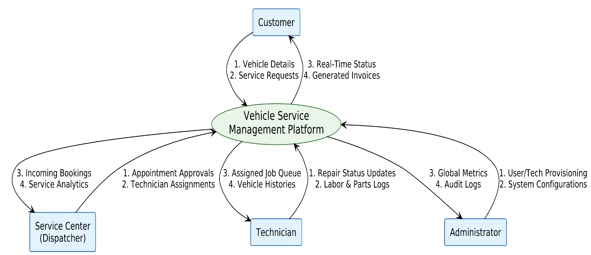

7.1.2 Level 1 DFD
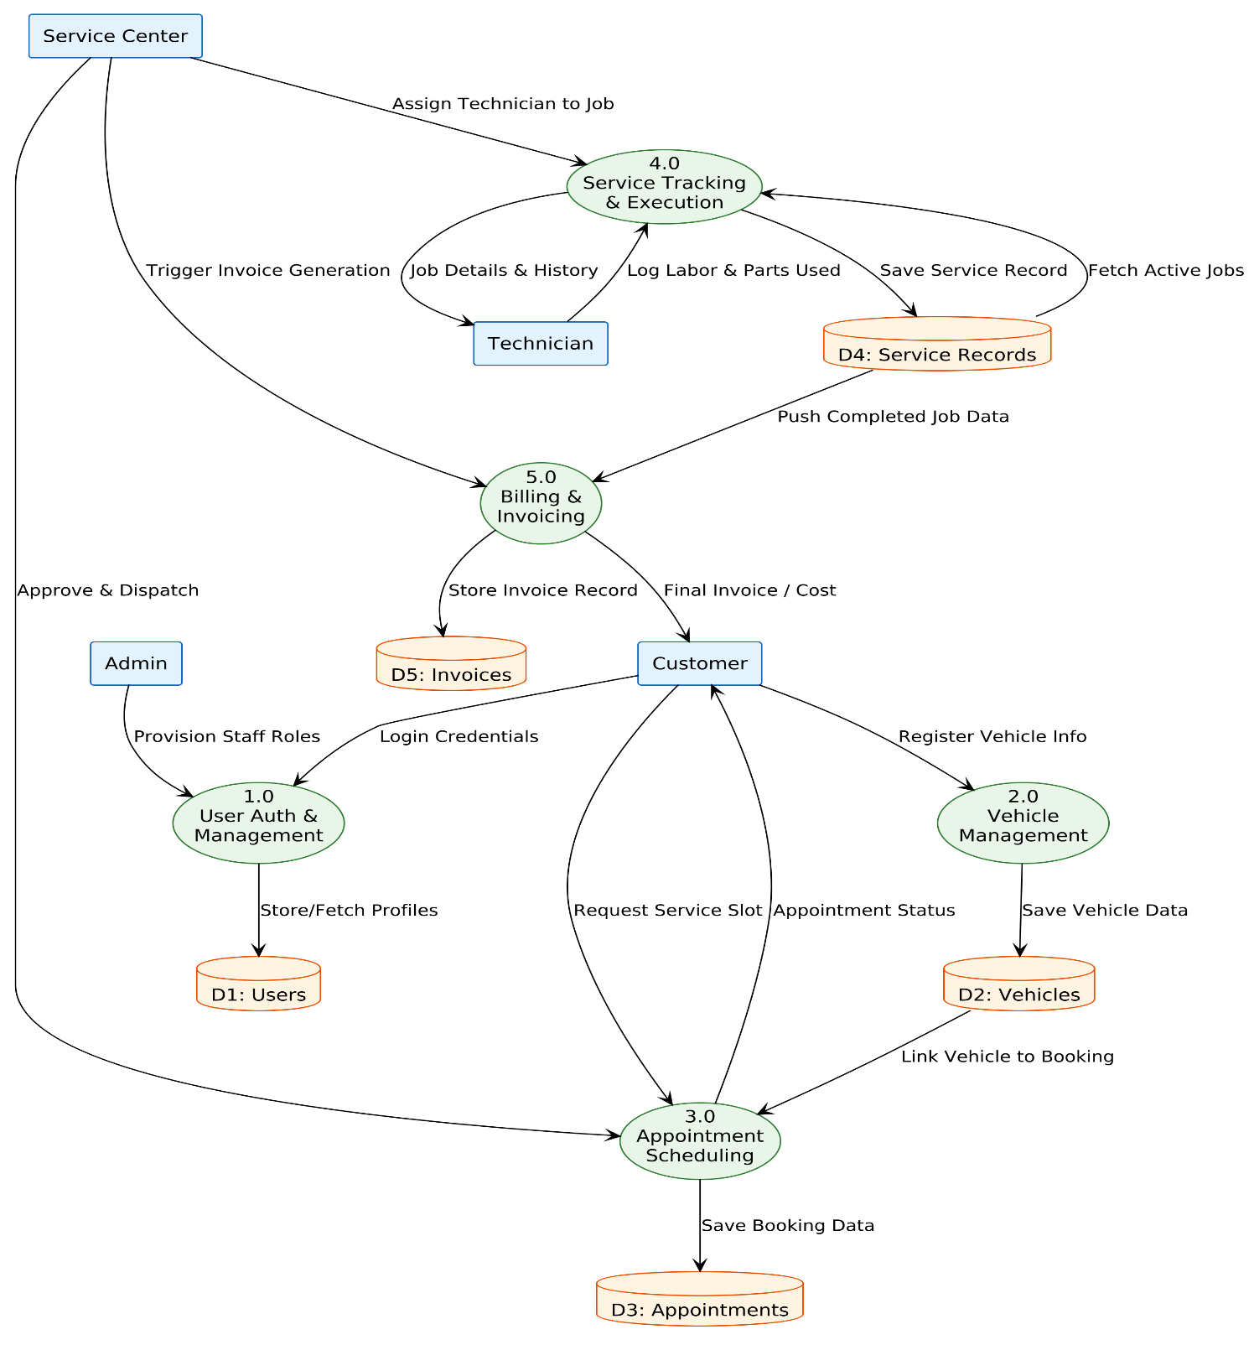

7.1.3 LEVEL 2 DFD
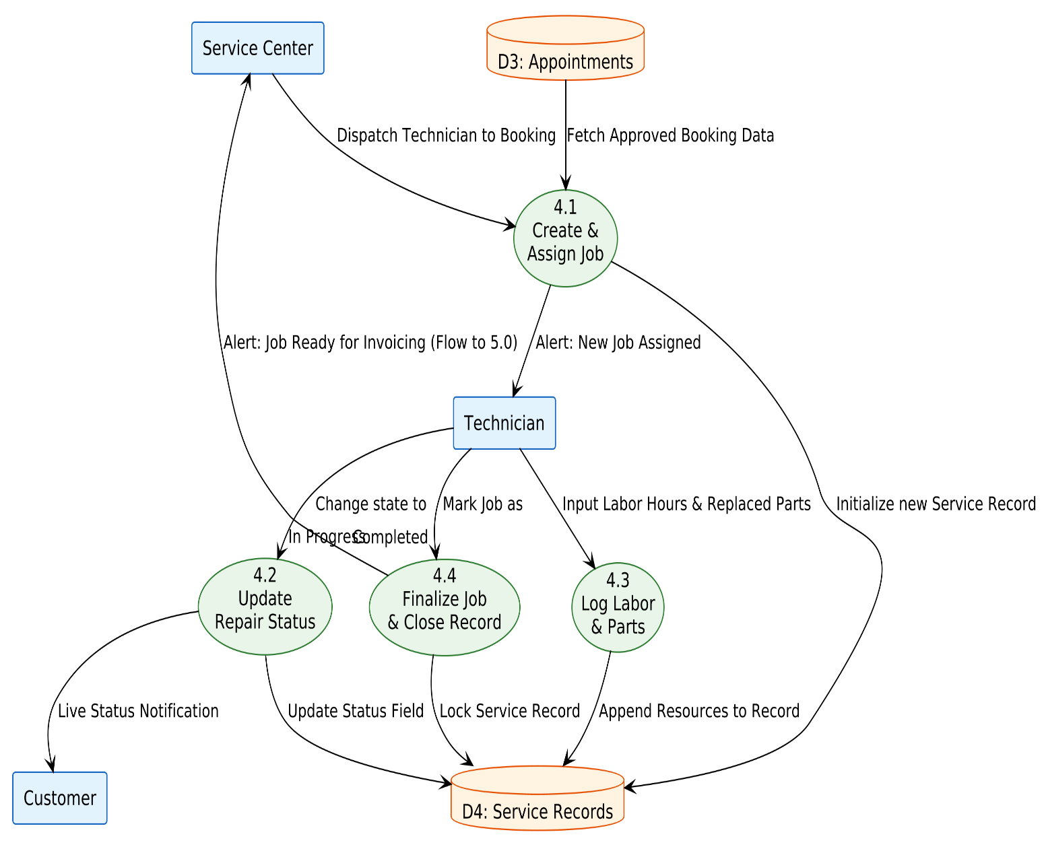

7.2 FLOWCHART

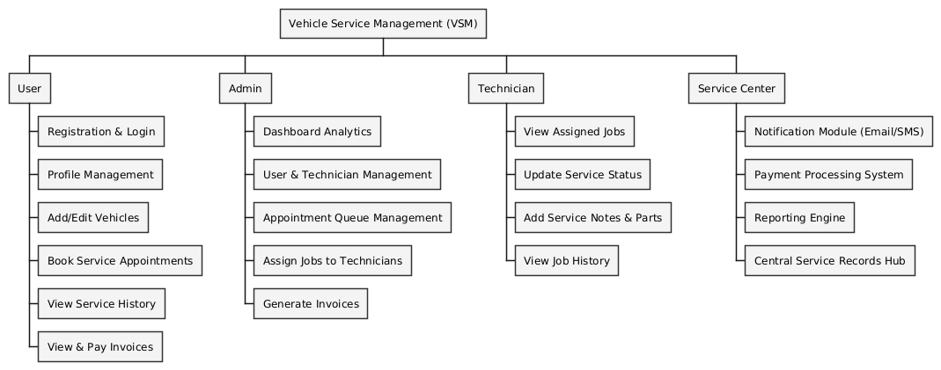

7.3 USECASE DIAGRAM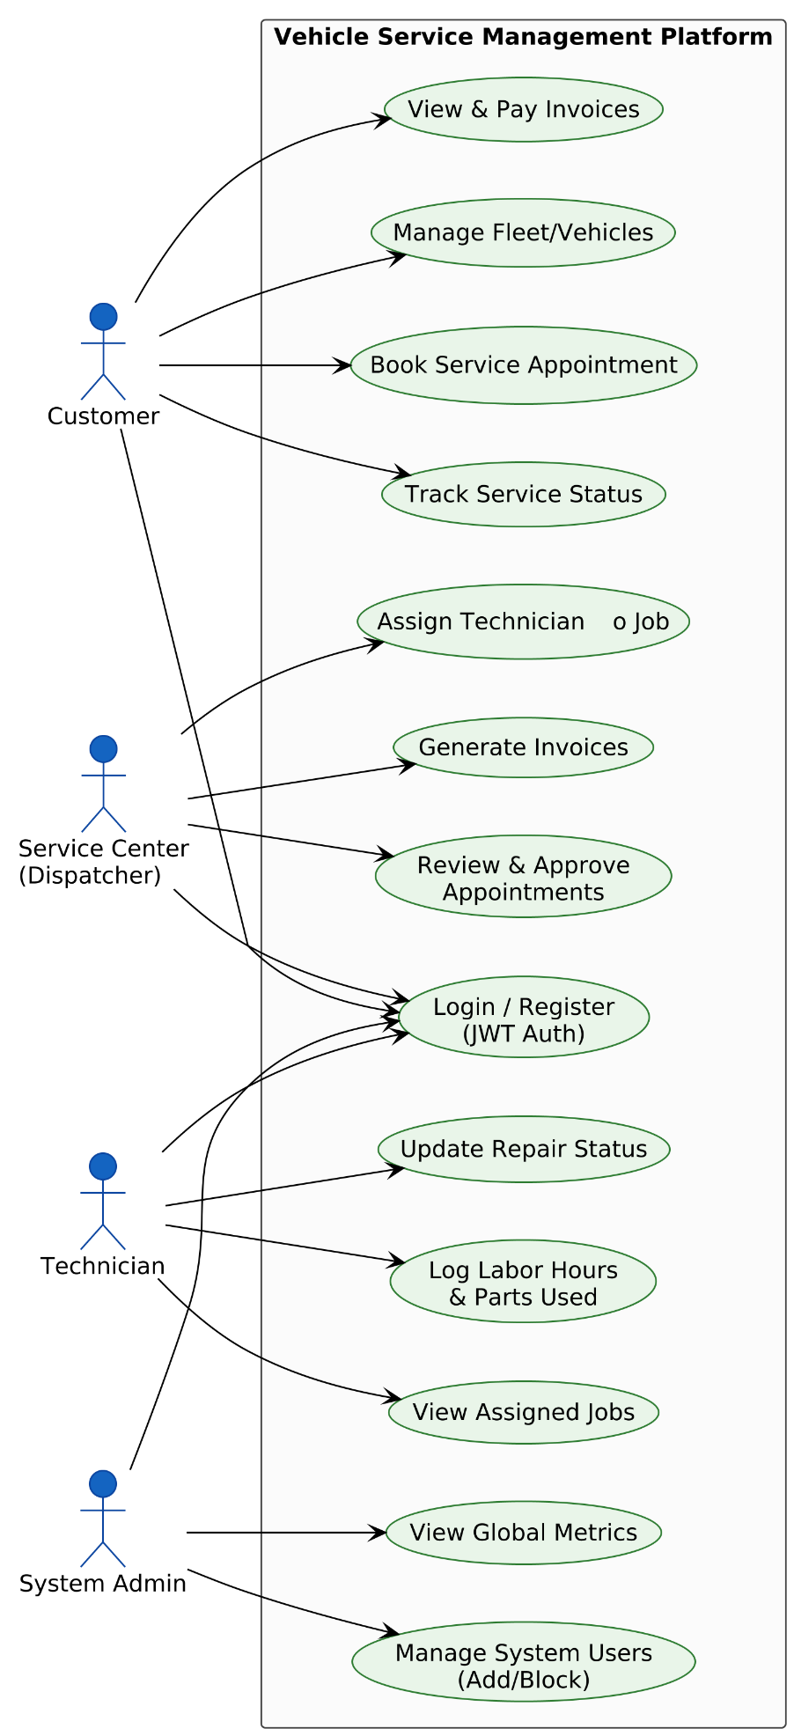

7.4 CLASS DIAGRAM

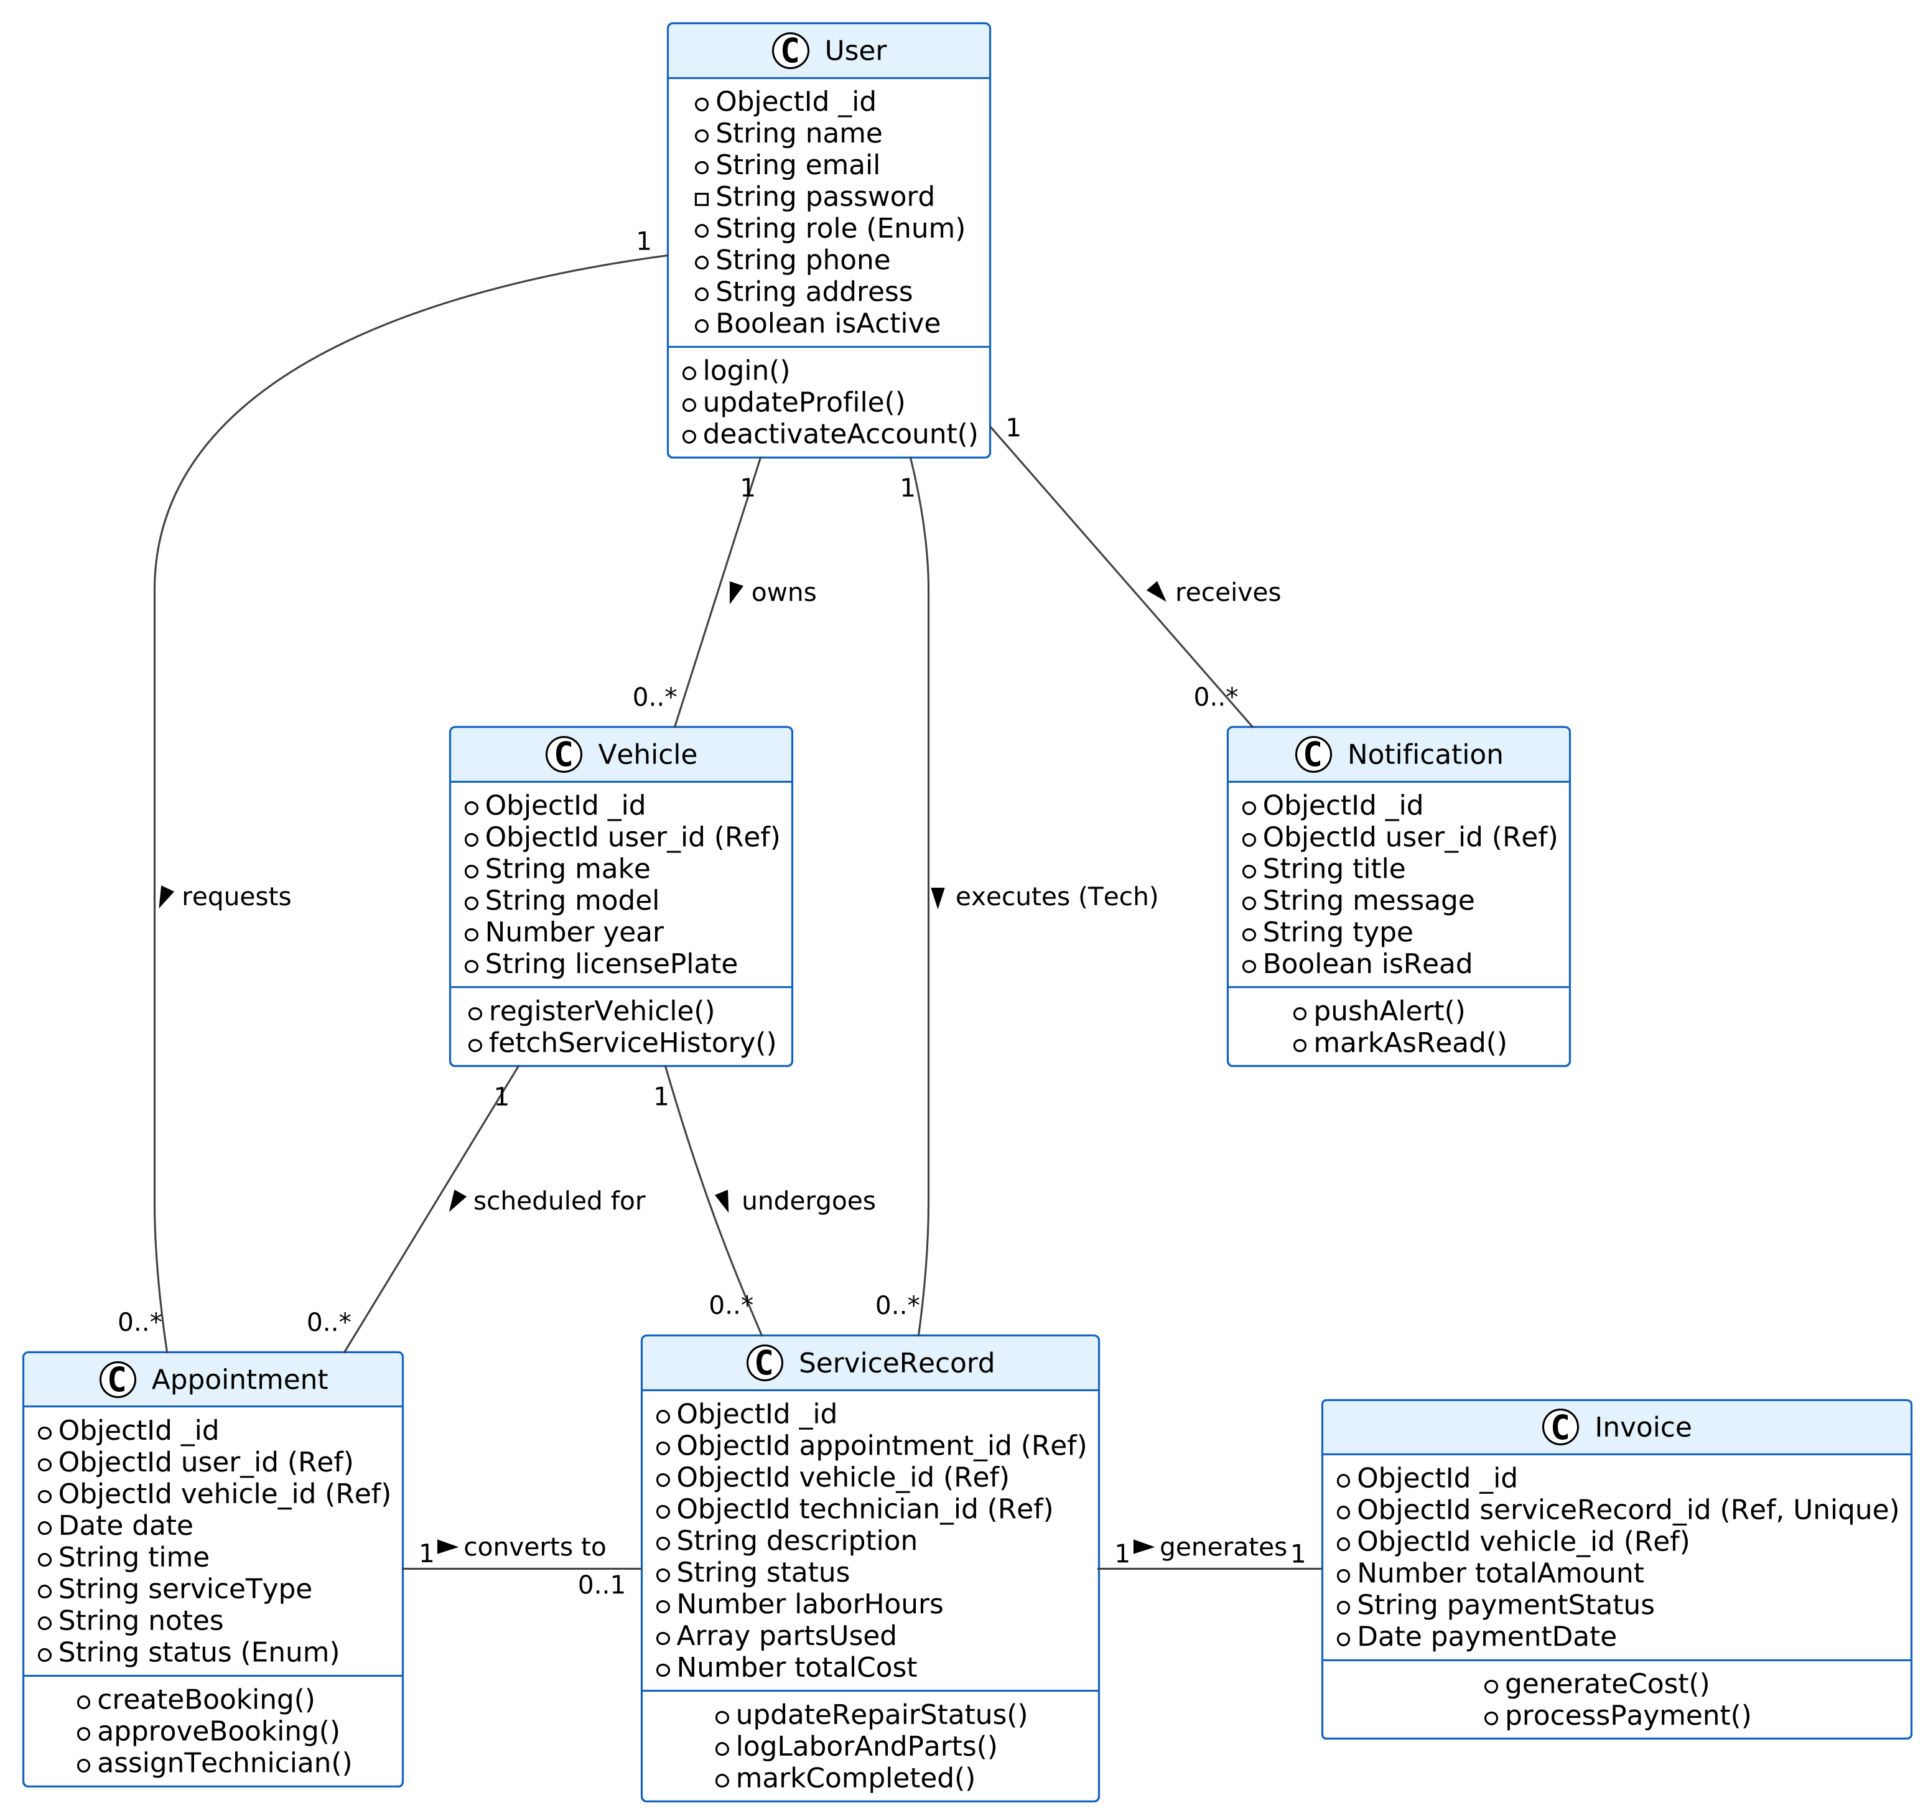

7.5 OBJECT DIAGRAM
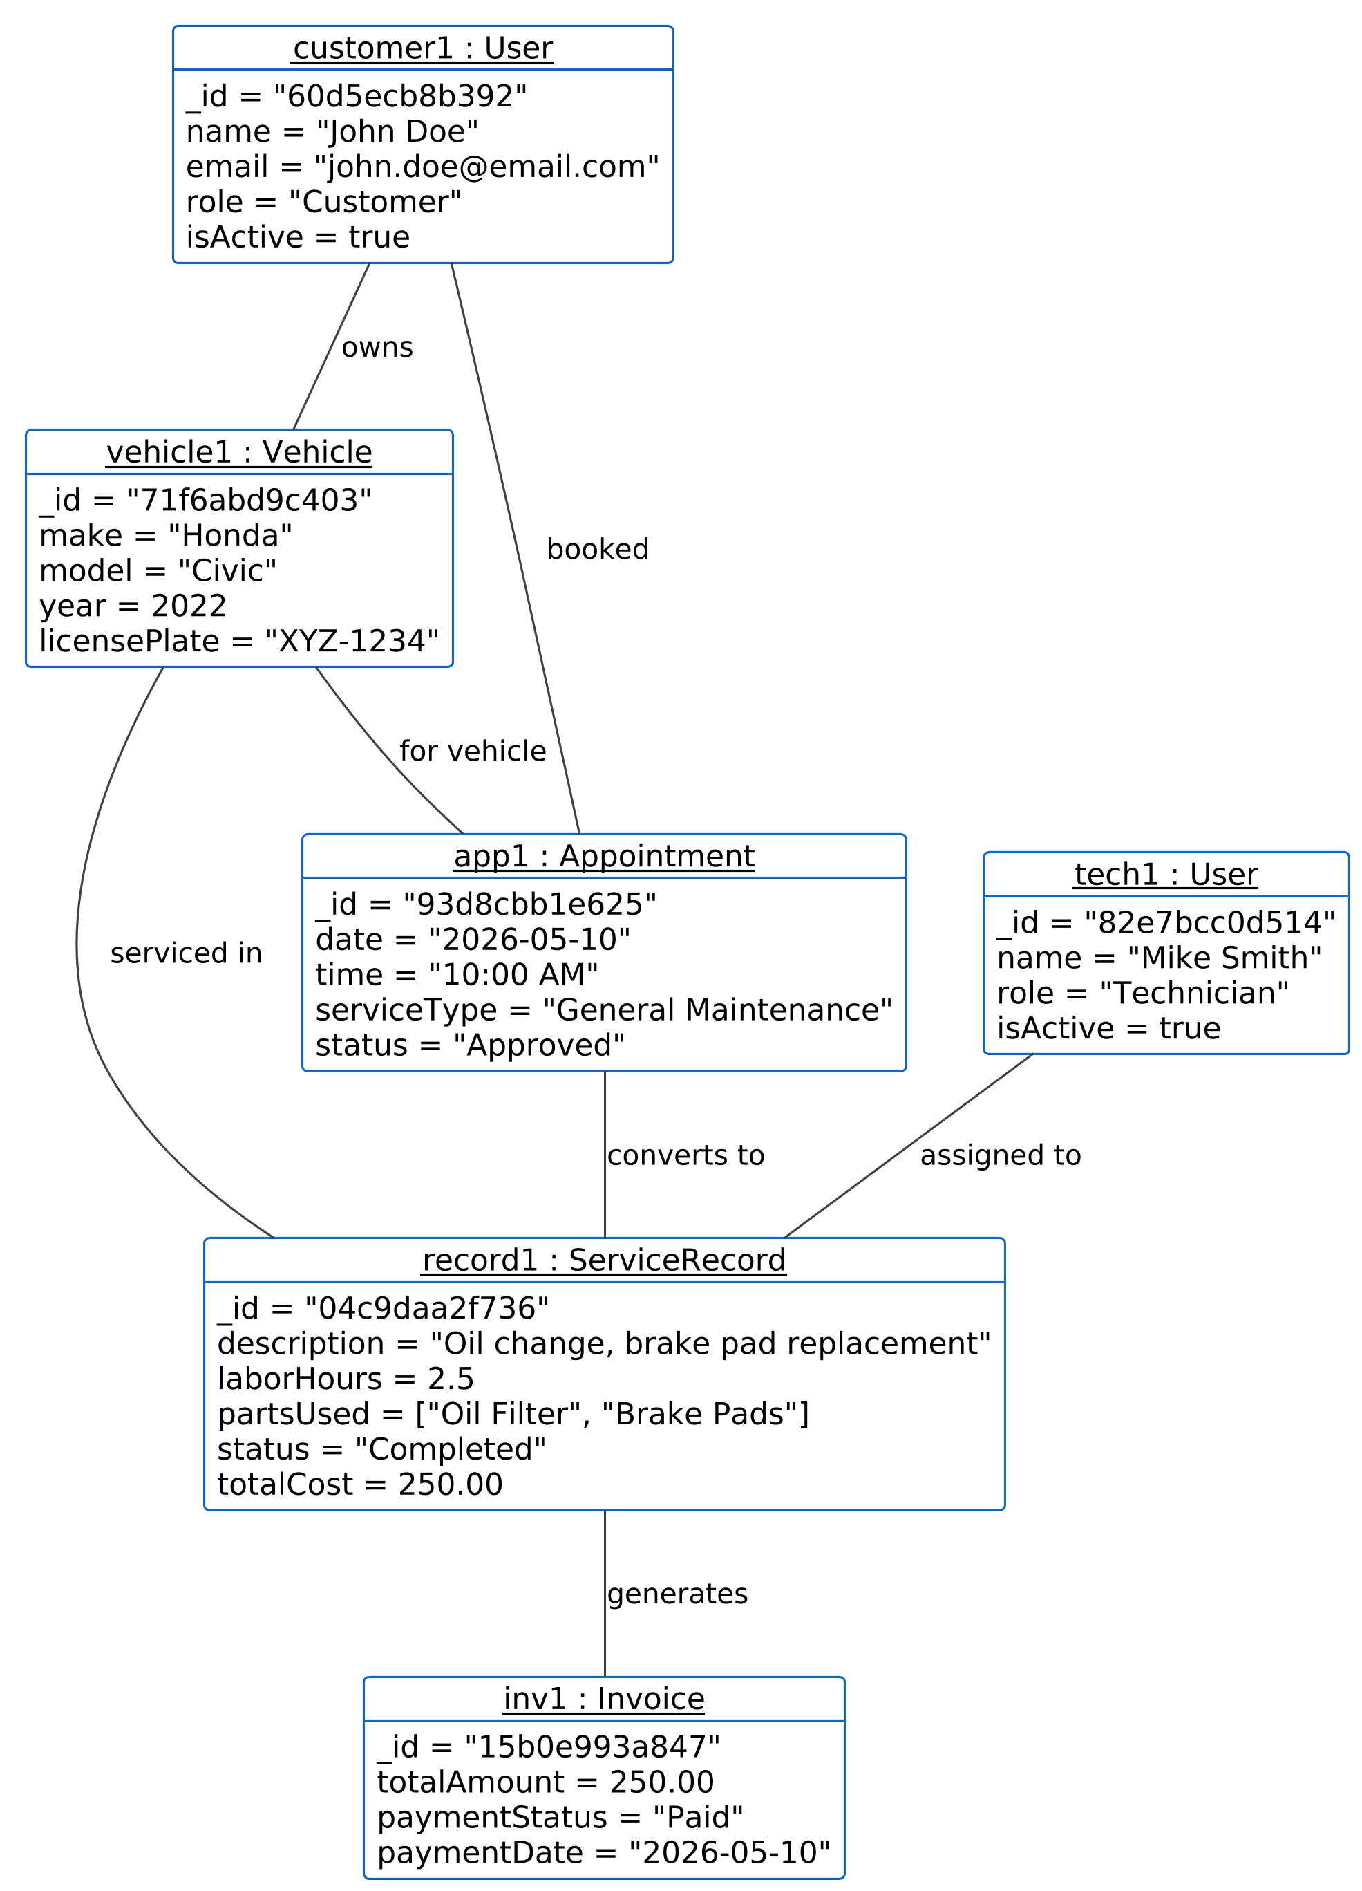

8. TESTING AND VALIDATION
To ensure the reliability, security, and performance of the Vehicle Service Management Platform, a comprehensive testing strategy was implemented across multiple phases of the software development lifecycle.
8.1 Unit Testing
Unit testing focuses on verifying the smallest parts of the application independently to ensure individual functions and components work as expected.
- Backend (Node.js/Express): Tested individual utility functions, such as the bcryptjs password hashing logic and the JSON Web Token (JWT) generation/verification methods.
- Frontend (React): Verified individual UI components (e.g., ensuring the <StatusBadge /> component renders the correct color for "Pending" vs. "Completed"). Tested Redux Toolkit slices to ensure state updates correctly when mock API data is dispatched.

8.2 Integration Testing
Integration testing ensures that different modules interact flawlessly when combined.
- API & Database Integration: Validated that Mongoose models correctly save data to MongoDB. For example, testing the Create Appointment route to ensure it successfully creates an Appointment document and accurately references the specific User and Vehicle ObjectIDs.
- Frontend & API Integration: Utilized tools like Postman to test REST API endpoints, ensuring the Express backend returns the correct JSON payload to the React frontend, and that the frontend dynamically updates the UI without errors.

8.3 System Testing
System testing evaluates the fully integrated application against the project requirements.
- Role-Based Access Control (RBAC) Testing: Crucial for system security. Tested the routing logic by attempting to access the Admin dashboard using a Customer JWT. The backend middleware (roleMiddleware.js) successfully blocked unauthorized requests, returning a 403 Forbidden error.

- Service Lifecycle Testing: Walked through the entire core workflow from start to finish: A Customer books a service ➔ Service Center approves and assigns a Technician ➔ Technician logs labor and completes the job ➔ System automatically generates an invoice.

8.4 User Acceptance Testing (UAT)
UAT validates the system from the end-user's perspective to ensure it solves the initial problem statement effectively.
- Usability: Verified that the UI is intuitive across different devices (desktop, tablet, mobile). Ensured that Customers can easily navigate to their generated invoices and that Technicians can comfortably tap to update job statuses on a smaller mobile screen while on the garage floor.
- Visual Feedback: Confirmed that react-hot-toast displays success and error notifications immediately after a user performs an action, providing a high-end feel and preventing users from clicking "Submit" multiple times.

8.5 Core Test Case Scenarios Executed
Instead of standard functional checks, several critical edge cases were tested to guarantee system integrity:
- Authentication Validation: When logging in with invalid or malformed credentials, the system successfully denies access and displays an "Invalid Email or Password" notification rather than crashing.
- Security Boundary Checks: When a standard Customer attempts to hit the API endpoint to view all system users, the backend middleware actively intercepts and blocks the request.
- Booking Initialization: When a Customer books an appointment for a registered vehicle, the database successfully saves the record and defaults the status strictly to "Pending Approval".
- Workflow Completion: When a Technician changes a Service Record status to "Completed," the system locks the record from further edits and triggers the automated billing logic.
- Financial Integrity Check: When attempting to force the system to generate a second invoice for a previously completed Service Record, the database's unique indexing rejects the creation, completely eliminating the risk of duplicate billing.

9. FRONT-END DESCRIPTION
The client-side of the Vehicle Service Management Platform is designed as a highly responsive, dynamic Single Page Application (SPA). It is engineered to provide a seamless, premium user experience while efficiently managing complex data states across multiple user roles.
9.1 Core Technologies
The front-end architecture is built upon a modern React ecosystem:
- React.js (via Vite): Chosen for its component-based architecture, allowing for the creation of reusable UI elements. Vite is utilized as the build tool to provide extremely fast Hot Module Replacement (HMR) during development and optimized, minified bundles for production.
- Redux Toolkit: Serves as the centralized state management solution. Instead of prop-drilling data through multiple component layers, Redux Toolkit utilizes "slices" (authSlice, appointmentSlice, serviceRecordSlice) to store global data. This ensures that when a service status updates, all subscribed components across the application reflect the change instantly.
- Tailwind CSS: A utility-first CSS framework used to construct the platform's premium design system. It enables rapid UI development, ensuring the application is fully responsive (mobile-first) and visually consistent, utilizing modern aesthetics like Glassmorphism and tailored color palettes.
- React Router DOM: Manages the client-side routing. It enables smooth navigation between pages without reloading the browser window, maintaining the fast SPA experience.

9.2 Component Architecture
To ensure code maintainability, the React application follows a strict hierarchical directory structure:
- Pages Directory (/pages): Contains the high-level portal views corresponding to specific user roles, such as AdminDashboard, CustomerDashboard, ServiceCenterDashboard, and TechnicianDashboard.
- Layouts Directory (/components/layout): Houses structural components like the Sidebar and Navbar. These components dynamically render different navigation links based on the active user's role (extracted from the Redux auth state).

- Common/UI Directory (/components/common): Contains reusable presentation components such as reusable Card wrappers, form inputs, data tables, and dynamic StatusBadge components that automatically change colors based on the data passed to them (e.g., Green for "Completed", Orange for "Pending").

9.3 Client-Server Communication
- Axios HTTP Client: The front-end utilizes Axios to handle all asynchronous API calls to the Node.js backend.
- JWT Interception: Axios is configured to automatically attach the user's JSON Web Token (JWT) to the Authorization header of outgoing requests, ensuring seamless access to protected backend routes.
- Visual Feedback: During API calls, the front-end utilizes react-hot-toast to provide immediate visual feedback. Users are presented with loading spinners during data fetching, followed by high-end success or error toast notifications based on the server's response.

9.4 Role-Based Routing (Protected Routes)
Security on the front-end is enforced via Protected Route wrappers. When a user attempts to access a specific URL (e.g., /admin), the React Router intercepts the navigation request. It checks the Redux authSlice to verify if the user is authenticated and possesses the correct role. If the check fails, the user is immediately redirected to a safe fallback page, such as the Login screen or their designated dashboard, preventing unauthorized interface access.

10. BACK-END DESCRIPTION
The back-end of the Vehicle Service Management Platform operates as a robust, secure, and highly scalable RESTful API. Developed using the Node.js runtime and the Express.js framework, the server acts as the central nervous system of the platform, processing complex business logic, enforcing security policies, and interacting with the database.

10.1 Core Server Architecture
The API is structured using a strict, modular design pattern that separates concerns to ensure long-term maintainability:
- Models (/models): Define the data structure. Built using Mongoose (an Object Data Modeling library), these schemas dictate exactly how data like Users, Vehicles, Appointments, and Invoices must be formatted before saving to the MongoDB database. They enforce strict data validation and relationship mappings (e.g., linking a Vehicle to a specific User's ObjectId).
- Controllers (/controllers): House the core business logic. When a request hits the server, the controller executes the required operations—such as calculating invoice totals, updating the service lifecycle state machine, or querying the database for a technician's specific job queue.
- Routes (/routes): Act as the traffic directors. They define the HTTP endpoints (e.g., POST /api/appointments) and map incoming client requests to their corresponding controller functions.

10.2 Middleware & Security Infrastructure
The back-end utilizes custom middleware functions (/middleware) to intercept requests before they reach the controllers, ensuring maximum security and stability:
- Authentication Middleware (authMiddleware.js): Extracts the JSON Web Token (JWT) from the HTTP request header. It cryptographically verifies the token to confirm the user's identity before allowing access to protected data.
- Role-Based Authorization (roleMiddleware.js): Works in tandem with authentication. Once a user is verified, this middleware checks their specific role (Admin, Customer, Technician, Service Center). If a user attempts to access an

- endpoint outside their clearance level, the middleware instantly rejects the request with a 403 Forbidden status.
- Global Error Handling (errorMiddleware.js): A centralized error catcher that prevents the Node.js server from crashing during unexpected faults. It intercepts database errors or malformed requests and returns clean, readable JSON error messages to the front-end.

10.3 Database Integration (MongoDB)
- NoSQL Flexibility with Relational Integrity: While MongoDB is a NoSQL database, the platform leverages Mongoose to enforce relational integrity. For example, an Invoice document cannot exist without a valid reference to a ServiceRecord.
- Data Protection: User passwords are never stored in plain text. Prior to database insertion, the User model utilizes bcryptjs to hash the password with a generated salt. When a user logs in, the backend compares the hashed strings, ensuring that even in the event of a database breach, user passwords remain completely secure.
- Unique Indexing: To prevent critical financial errors, the database utilizes unique indexing on the Invoice schema, mathematically guaranteeing that duplicate bills cannot be generated for the same completed service record.

10.4 Automated Data Seeding
To facilitate rapid deployment and testing, the back-end includes utility scripts (/utils/seedAdmin.js, /seeder/). These scripts automatically populate the database with default administrative accounts, mock service centers, and realistic operational data, ensuring the platform is immediately functional upon initial boot.

11. NOVELTY & UNIQUE SELLING POINTS (USPS)
1. Strict State-Machine Driven Lifecycle
Unlike traditional CRUD (Create, Read, Update, Delete) applications where statuses can be arbitrarily changed, this platform implements a strict Linear State Machine. A service request must mathematically flow through defined checkpoints: Pending → Approved → Assigned → In Progress → Completed → Invoiced → Paid. This guarantees absolute data integrity and prevents illogical operational states (e.g., generating an invoice before a technician completes the repair).

2. Omni-Role RBAC Architecture
The system departs from standard Admin/User dynamics by offering a full 4-Tier Role-Based Access Control (RBAC) architecture. It provides highly specialized, deeply isolated dashboard experiences for:
- Customers: Fleet tracking, service booking, and secure payment gateways.
- Technicians: Active job queues, status updates, and labor logging.
- Service Centers: Dispatch routing, resource allocation, and billing management.
- System Admins: Global oversight, metric aggregations, and deep-data management.

3. Atomic Billing & Strict One-Time Invoicing
To solve the common software issue of duplicate billing, the platform introduces a Hardened Invoicing Engine. It utilizes database-level uniqueness constraints and multi-layer backend validation to ensure that one service record can strictly generate only one invoice. The UI dynamically reacts to these backend locks, immediately transitioning action buttons into immutable success badges to prevent accidental double-charging.

4. Advanced Data Preservation (Soft-Delete & Cascade Purging)
Rather than executing destructive data deletions by default, the platform utilizes a Production-Grade Soft-Delete Architecture. Deactivated users immediately lose access, but their historical service and vehicle data are preserved for business auditing and metrics. Conversely, for GDPR compliance or absolute data purging, administrators have access to an atomic Cascade Purge operation that recursively wipes all associated records across 6 different database collections, ensuring zero "orphaned" data remains.

5. Premium "Glassmorphism" Design System
The presentation layer breaks away from generic web templates by implementing a highly customized, premium Glassmorphism Design Language using Tailwind CSS. It features:
- Dynamic, persistent Dark/Light modes.
- High-performance CSS micro-animations and blur effects.
- Non-blocking, real-time notification toasts that replace intrusive browser alerts, providing a seamless, modern SaaS application feel.

6. Zero-Trust Backend Synchronization
The backend employs a "zero-trust" approach to frontend requests. Even if UI buttons are manipulated or network latency occurs, backend controllers independently cross-reference user roles, payment statuses, and service completion flags before executing state changes. This ensures the entire multi-tenant system remains completely synchronized and secure against race conditions.

12. CONCLUSION
The development of the Vehicle Service Management Platform successfully addresses the critical operational bottlenecks prevalent in the modern automotive service industry. By transitioning away from disjointed, manual record-keeping systems and paper-based tracking, this project delivers a highly cohesive, secure, and fully digitized Software-as-a-Service (SaaS) solution.
The successful implementation of the MERN stack—combined with a strict Role-Based Access Control (RBAC) architecture—proves the viability of centralized digital management for garage operations. The platform effectively bridges the communication gap between customers, technicians, and service center managers. Customers are empowered with unprecedented transparency regarding their vehicle's real-time repair status, while technicians are equipped with a streamlined digital clipboard to track labor and parts efficiently.
Furthermore, the integration of a strict service lifecycle state machine guarantees that data integrity is maintained at every step, culminating in automated, error-free financial invoicing. Ultimately, this project not only improves the operational speed and administrative accuracy of service centers but significantly elevates the end-user experience, proving to be a highly effective, production-ready solution for modern vehicle fleet management.

13. FUTURE SCOPE & ENHANCEMENTS
While the current iteration of the Vehicle Service Management Platform delivers a fully functional, production-ready operational workflow, the system's modular MERN architecture allows for several powerful future integrations. To further enhance the platform's capabilities, the following features are proposed for future development phases:
- Payment Gateway Integration:
Integration of secure, third-party payment processors (such as Stripe or PayPal) directly into the Customer Portal. This will allow customers to settle their generated invoices online instantly, closing the financial loop entirely within the application.
- Predictive Maintenance (AI Integration):
Implementing a machine learning module that analyzes a vehicle’s service history, mileage, and make/model data to automatically predict when the next service (e.g., oil change or brake pad replacement) is required. The system could then send automated preventative maintenance alerts to the customer.
- Live Inventory Management:
Expanding the database to include a live "Spare Parts Inventory" schema. When a Technician logs parts used during a repair, the system would automatically deduct those items from the garage's digital stock and alert the Service Center manager when supplies fall below a minimum threshold.
- Real-Time Chat Support:
Incorporating WebSockets (via Socket.io) to enable a live chat feature. This would allow customers to communicate directly with their assigned technician or the service center dispatcher for quick updates or approvals regarding unexpected repair costs.
- Cross-Platform Mobile Application:
Leveraging the existing Node.js API to develop a dedicated mobile application using React Native. A native app would allow for the implementation of push notifications on customer smartphones, ensuring they never miss a critical service update.

14. REFERENCES
- React.js Documentation: Meta Platforms, Inc. (2026). React: The library for web and native user interfaces. Retrieved from https://react.dev/
- Node.js Documentation: OpenJS Foundation. (2026). Node.js v20.x Documentation. Retrieved from https://nodejs.org/en/docs/
- Express.js Framework: OpenJS Foundation. (2026). Express: Fast, unopinionated, minimalist web framework for Node.js. Retrieved from https://expressjs.com/
- MongoDB & Mongoose ODM: MongoDB, Inc. (2026). MongoDB Manual & Mongoose Documentation. Retrieved from https://www.mongodb.com/docs/ and https://mongoosejs.com/docs/
- Redux Toolkit: Redux. (2026). Redux Toolkit: The official, opinionated, batteries-included toolset for efficient Redux development. Retrieved from https://redux-toolkit.js.org/
- Tailwind CSS: Tailwind Labs. (2026). Tailwind CSS: Rapidly build modern websites without ever leaving your HTML. Retrieved from https://tailwindcss.com/docs
- JSON Web Tokens (JWT) Standards: Internet Engineering Task Force (IETF). (2015). RFC 7519: JSON Web Token (JWT). Retrieved from https://datatracker.ietf.org/doc/html/rfc7519
- RESTful API Architectural Principles: Fielding, R. T. (2000). Architectural Styles and the Design of Network-based Software Architectures (Ph.D. dissertation). University of California, Irvine.

